
DEPARTMENT OF AEROSPACE ENGINEERING
U20AE404- ADVANCED SOLID MECHANICS
UNIT I / BEAM & TRUSS ANALYSIS

- A steel rod of 3cm diameter enclosed centrally in a hollow copper tube of external diameter 5cm and internal diameter of 4cm. The composite bar is then subjected to an axial pull of 45000N. If the length of each bar is equal to 15cm. Determine (i). The stresses in the rod and tube. (ii). Load carried by each bar. Take Es=2.1×10⁵N/mm² and Ec=1.1×10⁵N/mm². (Nov/Dec 2016 – R 2013) (Nov/Dec 2017 – R 2013) (Nov/Dec 2015 – R 2013)

- A reinforced concrete column 300mm × 300mm has 4 reinforcing steel bars of 25mm diameter each corner. Find the safe axial load on the column when the concrete is subjected to a stress of 5 N/mm². What is the corresponding stress in steel. Take Es/Ec =18. (Nov/Dec 2016 – R 2013) (May/June 2013 – R 2009)

- A steel rod of 4m long and 30mm diameter is connected to two grips and the rod is maintained at a temperature of 70 ºC. Find out the force exerted by the rod after it has been cooled at 25ºC. (i).If the ends do not yield (ii). If the ends yield by 1.5mm. Take E=2.1 x 10⁵ N/mm², α=12 x 10-6 per ºC.(April/May 2019 – R 2017) (May/June 2016 – R 2013)

- A steel rod of 30mm diameter passes centrally through a copper tube of 60mm external diameter and 50mm internal diameter. The tube is closed at each end by rigid plates of negligible thickness. Calculate the stress developed in copper and steel when temperature of the assembly is raised by 60ºC. Take E for steel and copper as 2 x 10⁵N/mm² and 1 x 10⁵ N/mm² respectively. The value of co-efficient of linear expansion for steel and copper is given as 12 x 10⁻⁶ per ºC and 18 x 10⁻⁶ per ºC respectively. (April/May 2019 – R 2017) (May/June 2016 – R 2013)

- A bar of 30mm diameter is subjected to a pull of 60KN. The measured extension on gauge length of 200mm is 0.1mm and change in diameter is 0.004mm. Calculate (i)Young’s Modulus (ii). Poisson’s ratio (iii).Bulk Modulus (April/May 2019 – R 2017) (Nov/Dec 2013 – R 2009)

- A cantilever 1.5 m long is loaded with a uniformly distributed load of 2 KN/m run over a length of 1.25 m. from the free end. It also carries a point of 3 KN at a distance of 0.25 m from the free end. Draw the shear force and bending moment diagrams of the cantilever. (Nov/Dec 2017 – R 2013)

- A simply supported beam of 7m span has a load of 12KN/m uniformly distributed over 3m. It is 1.5m away from right. In addition it has a point load of 8KN at 2.5m from the left hand support. Also calculate maximum bending moment on the section. (Nov/Dec 2016 – R 2013)

- A beam of 8m span simply supported at its end carries loads of 2KN and 5KN at a distance of 3m and 6m respectively. In addition, the beam carries a UDL of 4KN/m for its entire length. Draw the S.F and B.M diagrams. (Nov/Dec 2017 – R 2013)

- A simply supported beam of length 5m carries a UVL of 800N/m run at one end to zero at the other end. Draw the S.F and B.M diagrams for the beam. Also find the portion and magnitude of maximum bending moment. (Nov/Dec 2015 – R 2013)

- A simply supported beam of length 10m carries the uniformly distributed load and two point loads as shown in fig. Draw the S.F and B.M diagram for the beam. (April/May 2017 – R 2013) (Nov/Dec 2015 – R 2013)
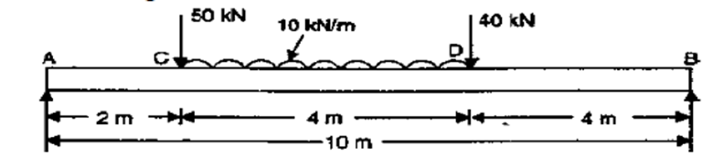
UNIT 2
ENERGY METHODS
- A tensile test was conducted on a mild steel bar. The following data was obtained from the test. (i). Diameter of the steel bar = 3cm
(ii). Gauge length of the bar = 20cm
(iii). Load at elastic limit = 250KN
(iv). Extension at a load of 150KN = 0.21mm
(v). Maximum load = 380KN
(vi). Total Extension = 60mm
(vii). Diameter of the rod at the failure = 2.25 cm
Determine (a). the Young’s Modulus (b). the stress at elastic limit (c). the percentage elongation (d). the percentage decrease in area. (Nov/Dec 2013 – R 2009)

- The bar as shown in fig. which is subjected to a tensile load of 150 KN. Find the diameter of the middle portion if the stress is limited to 160 N/mm2. Find also the length of the middle portion if the total elongation of the bar is 0.25mm.Take E = 200 GN/m². (Nov/Dec 2014 – R 2013) (April/May 2017 – R 2013)
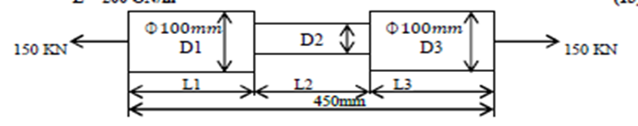
- A brass bar, having cross sectional area of 1000mm² is subjected to axial force as shown in fig. Find the total elongation of the bar. Take E = 1.05×10⁵N/mm²
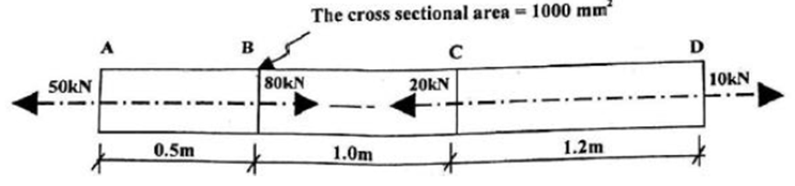
- Derivation of bending equation (or) Derivation of flexural formula for pure bending.

- Calculate the maximum shear stress induced in a cast iron pipe external diameter 40mm, of internal diameter 20mm and of length 4m when the pipe is supported at its end carries a point load of 80N at its centre.

- A tember beam of rectangular section 250mm deep by 75mm wide is to be reinforced by steel strips 8mm thick on both sides. The composite beam is simply supported at its ends 4m apart and carries a load of 8 KN is applied at the mid span. Find the maimum bending stress in the steel and timber at the mid span. Esteel = 2.1×10⁵N/ mm² and Etimber = 0.12×10⁵N/ mm². (May/June 2016 – R 2013) (April/May 2019 – R 2017) (Nov/Dec 2019 – R 2017)

- Derive the torsional equation T/J = τ/R =Cθ/L. (Nov/Dec 2014 – R 2013)

- Two shafts of the same material and of same lengths are subjected to the same torque, if the first shaft is of a solid circular section and the second shaft in a hollow circular section, whose internal diameter is 2/3 of the outside diameter and maximum shear stress developed in each shaft is the same, compare the weights of the shafts. (April/May 2019 – R 2017)

- A hollow cylindrical shaft has an external diameter of 120mm and the internal diameter is ¾ of external diameter. If the stress at a fibre inside is 36MPa due to torque applied. Find this torque the maximum shear stress and the angle of twist per unit length. Take C=85Mpa. (Nov/Dec 2018 – R 2013)

- A steel shaft ABCD having a total length of 2.4m consists of three lengths having different section as follows.AB is hollow having outside and inside diameters of 80mm and 50mm respectively and BC and CD are solid, BC having a diameter of 80mm and CD a diameter of 70mm. If the angle of twist is the same for each section, determine the length of each section and the total angle of twist if the maximum shear stress in the hollow portion is 50N/ mm². Take C= 8.2×104N/ mm². (Nov/Dec 2015 –
R 2013)
UNIT 3
BUCKLING OF COLUMNS

- A hollow shaft is 1m long and has external diameter 50mm. It has 20mm internal diameter for a part of the length and 30mm internal diameter for the rest of the length. If the maximum shear stress in it is not exceed E= 80N/mm², Determine the maximum power transmitted by it at a speed of 300 r.p.m. If the twist produced in the two portions of the shafts are equal, find the lengths of two portions. (Nov/Dec 2015 – R 2013)

- A hollow shaft, having an inside diameter 60% of its diameter is to replace a solid shaft transmitting the same power at the same speed. Calculate the percentage saving in material, if the material is to be used is also the same. (April/May 2017 – R 2013) (Nov/Dec 2018 – R 2013)

- A solid circular shaft, transmits 75KW power at 200 r.p.m. Calculate the shaft diameter if the twist in the shaft is not to exceed 1° in 2m length of shaft and shear stress is limited to 50 N/ mm2. Take C= 1×105 N/ mm². (Nov/Dec 2015 – R 2013) (May/June 2016 – R 2013)

- A close coiled helical spring of 10cm mean diameter is made up of 1cm diameter rod and has 20turns. The spring carries an axial load of 200N. Determine the shearing stress, taking modulus of rigidity 8.4×104 N/mm², determine the deflection when carrying this load. Also calculate the stiffness of the spring and frequency of free vibration for a mass hanging from it. (April/May 2019 – R 2017) (Nov/Dec 2018 – R 2013) (Nov/Dec 2015 – R 2013)
- Derive the expression for deflection of slope and deflection for a simply supported beam with point load at center. (Nov/Dec 2018 – R 2013)

- A beam 6m long, simply supported at its ends is carrying a point load of 50KN at its centre. The moment of inertia of the beam is given as equal to 78 ×10⁶mm⁴. If E for the material of the beam = 2.1 ×10⁵N/mm². Calculate (i) Deflection at centre of the beam. (ii). Slope and deflection. (Nov/Dec 2015 – R 2013) (Nov/Dec 2016 – R 2013) (Nov/Dec 2014 – R 2013) (April/May 2017 – R 2013)

- Determine: (i) Slope at the left support. (ii) Deflection under the load and (iii) maximum deflection of a simply supported beam of length 5m, which is carrying a point load of 5KN distance of 3m from the left end. Take E=2 ×10⁵N/ mm² and I=1×10⁸mm⁴ (Nov/Dec 2015 – R 2013)

- Derive the expression for deflection of slope and deflection for a simply supported beam with a uniformly distributed load. (May/June 2016 – R 2013) (May/June 2016 – R 2013)

- A beam of length 5m and of uniform rectangular section is supported at its ends and carries a UDL over entire span. Calculate the depth of the section if the maximum permissible bending stress is 8N/ mm² and central deflection is not exceed 10mm. Take E= 1.2 ×10⁴N/ mm²(April/May 2019 – R 2017) (Nov/Dec 2014 – R 2013) (April/May 2015 – R 2013)

- Derive the expression for deflection of slope and deflection for a simply supported beam with an eccentric point load.
UNIT 4
FAILURE ANALYSIS
- A beam of length 6m is simply supported at its end and carries two point loads of 48KN and 40KN at a distance of 1m and 3m respectively from the left support. Find (i). Deflection under each load (ii). Max.deflection and (iii). The point at which maximum deflection occurs. Take E=2 ×10⁵N/ mm2 and I= 85×10⁶mm⁴. (April/May 2019 – R 2017)
- A steel cantilever 6m long carries two point loads, 15kN at the free end and 25 kN at a distance of 2.5m from the free end. Find: (i) slope at the free end (ii) Deflection at the free end. Take E=2 ×10⁵N/ mm²and I= 1.3 ×10⁸mm⁴.

- A cantilever of length 4m carries a UDL of 8kN/m length over the entire length. If the section is rectangular of 150 mm × 260 mm, find the deflection and slope at the free end. Take E=2 ×10⁵N/ mm².

- A thin cylindrical tube 80 mm internal diameter and 5 mm thick is closed at its ends. It is subjected to an internal pressure of 6 N/ mm² and a torque of 2009600kN.m. Find the hoop stress, longitudinal stress, maximum and minimum principle stresses and maximum shear stress. (April/May 2015 – R 2013)

- A thin cylindrical of internal diameter 1.25m contains a fluid at an internal pressure of 2 N/ mm². Determinethe maximum thickness of the cylinder if:
(i)The longitudinal stress is not exceed 30 N/ mm2.
(ii). The circumferential stress is not exceed 45 N/ mm2. (April/May 2017 – R 2013) (April/May 2019 – R 2017) (Nov/Dec 2016 – R 2013)

- A closed cylindrical drum 600mm in diameter and 2m long has a shell thickness of 12mm. If it carries a fluid under a pressure of 3 N/ mm2, Calculate the longitudinal and hoop stress in the drum wall and also determine the change in diameter, change in length and change in volume of the drum. Take E=200Gpa and 1/m = 0.3. (May/June 2016 – R 2013)

- Calculate (i). the change in diameter, (ii). Change in length and (iii). Change in volume of a thin cylindrical shell 100cm diameter, 1cm thick and 5m long when subjected to an internal pressure of 3 N/ mm2. Take the value of E=2×105N/ mm2 and poisson’s ratio is 0.3. (Nov/Dec 2016 – R 2013) (Nov/Dec 2015 – R 2013) (Nov/Dec 2016 – R 2013)

- Use unit load method to find the deflection at the center of the beam shown in figure . Take E= 200 GPa and I=400x10⁶ mm⁴
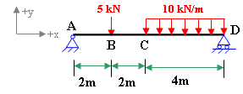
- A pin-jointed truss is shown in figure. Determine the vertical displacement of joint E by using unit load method. All the members have cross-sectional area of 250 mm² and same modulus of elasticity 200GPa.
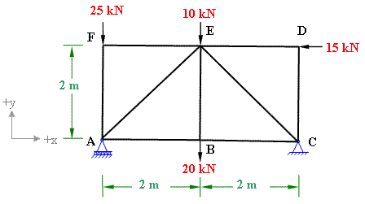

- Derive the expression for deflection of slope and deflection for a simply supported beam with a uniformly distributed load. (May/June 2016 – R 2013) (May/June 2016 – R 2013)

UNIT 5
DESIGN OF JOINTS
- A continuous beam ABC covers two consecutive spans AB & BC of length 4cm & 6cm carrying UDL of 6 kN/m and 10 kN/m resp. if the ends A & C are simply supported. Find the support moments at A,B& C. Draw also BMD and SFD.
- Find the moments and reactions for the given section by using moment distribution method shown in fig 1.
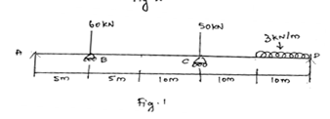

- Derive the expressions for starin energy due to axial load, bending stress.
- Explain castigiano’s theorem.
- Obtain the expression for a column with eccentric load.
- Write short notes on theories of failures.
- In a material the principal stresses are 60 MN/m², 48MN/m² and -36MN/m². Calculate:
(i) Total strain energy. (ii)Volumetric strain energy.(iii) Shear strain energy.
(iv) Factor of safety on the total strain energy criterion if the material yields at 120MN/m².
Take E = 200GN/m² and 1/m = 0.3.
- Explain short notes on fatigue and creep.
- A shaft is subjected to a maximum torque of 10kNm and a maximum bending moment of 7.5 kNm at a particular section. If the allowable equivalent stress in simple tension is 160MN/m² find the diameter of the shaft according to the following theories:
(i) Maximum shear stress theory.
(ii) Strain energy theory
(iii) Shear strain energy theory.

- A steelbar is placed between two copper bars, each having the same area and length as steel bar at 20ºC. At this stage, they are rigidly connected together at both the ends. When the temperature is raised to 320º C, the length of the bars increases by 1.5 mm. Determine the original length and final stresses in the bars.
Take: E_{S}= 220 GN/m²; E_{C}= 110 GN/m²; α_{S}=0.000012 per ºC; α_{C}=0.000175 per ºC.

